

数据库系统实验报告

作业名称： | SQL数据定义和操作
姓 名： | hidandelionzeroth
学 号：
电子邮箱：
联系电话：
指导老师：

2022年3月4日

实验名称
一、实验目的
1.掌握关系数据库语言SQL的使用。
2.面向某个应用定义数据模式和操作数据。
二、实验环境
1.数据库管理系统：MySQL
三、实验流程
新建数据库、数据表，插入数据
create <name of the database>;
create table <name of the table>(id int, name varchar(16));
insert into <name of the table>(<id>, ‘<name>’);
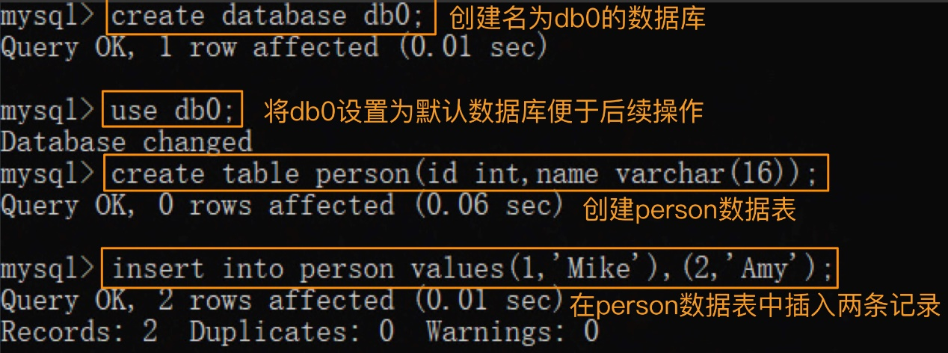
查看数据库、数据表属性、数据表内的数据
show databases;
show tables;
select * from <name of the table>;
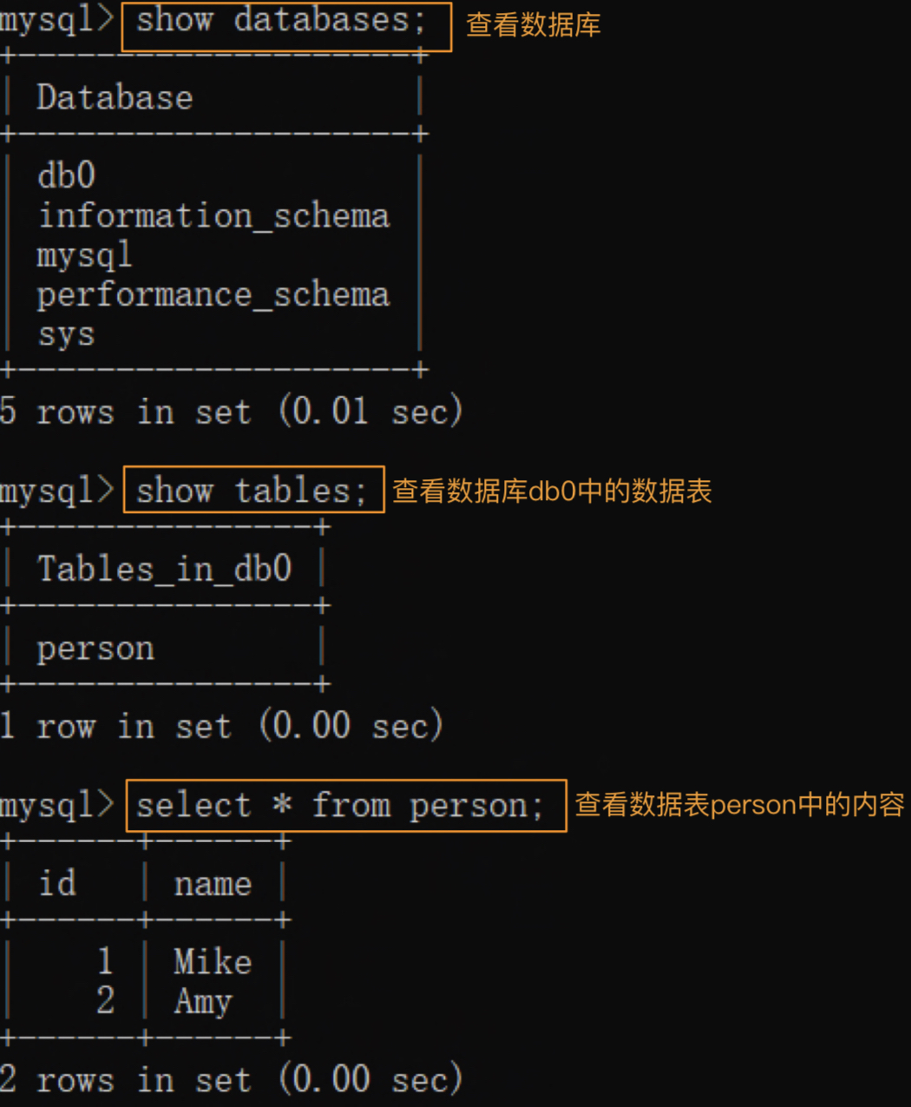
重命名数据库、数据表，修改数据
rename database <db_old_name> to <db_new_name> MySQL曾经提供这条指令来实现对数据库名的修改，但在现在的版本中已被取消。这里出于对称性考虑列出
rename table <db_old_name_table> to <db_new_name_table>;
update <name of the table> set <operation> where <content>;
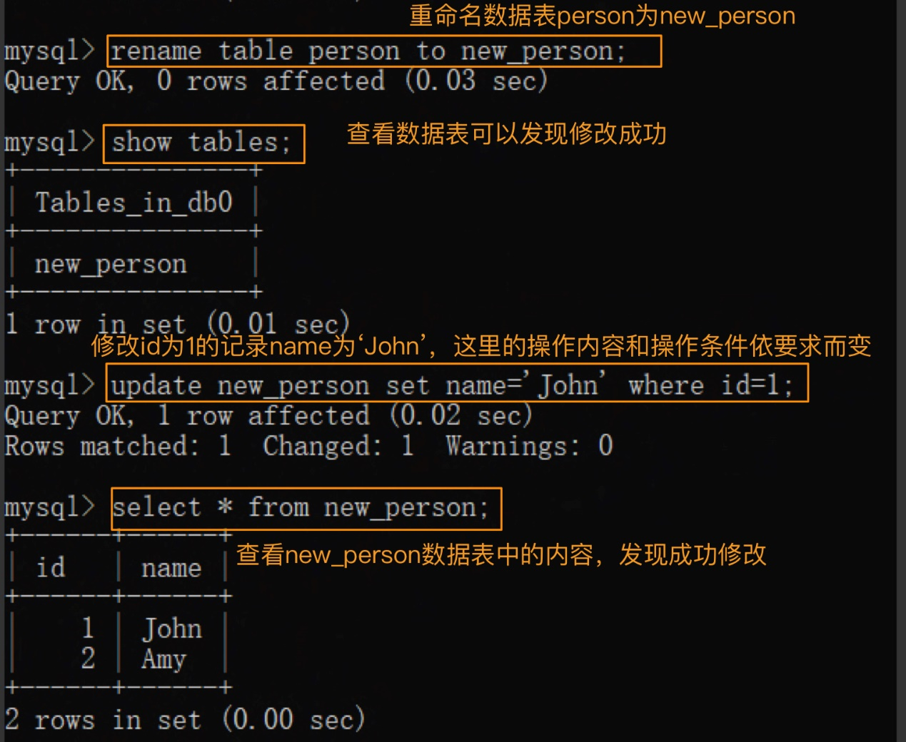
如果强求数据库名字的修改（即重命名数据库），数据量较小的情况下可以考虑建立新数据库，迁移所有数据表，再删除原来的数据库。即：
create database new_db_name;
rename table old_db_name.table1 to new_db_name.table1,
old_db_name.table2 to new_db_name.table2;
drop database old_db_name;
若数据量较大可以使用脚本批量修改
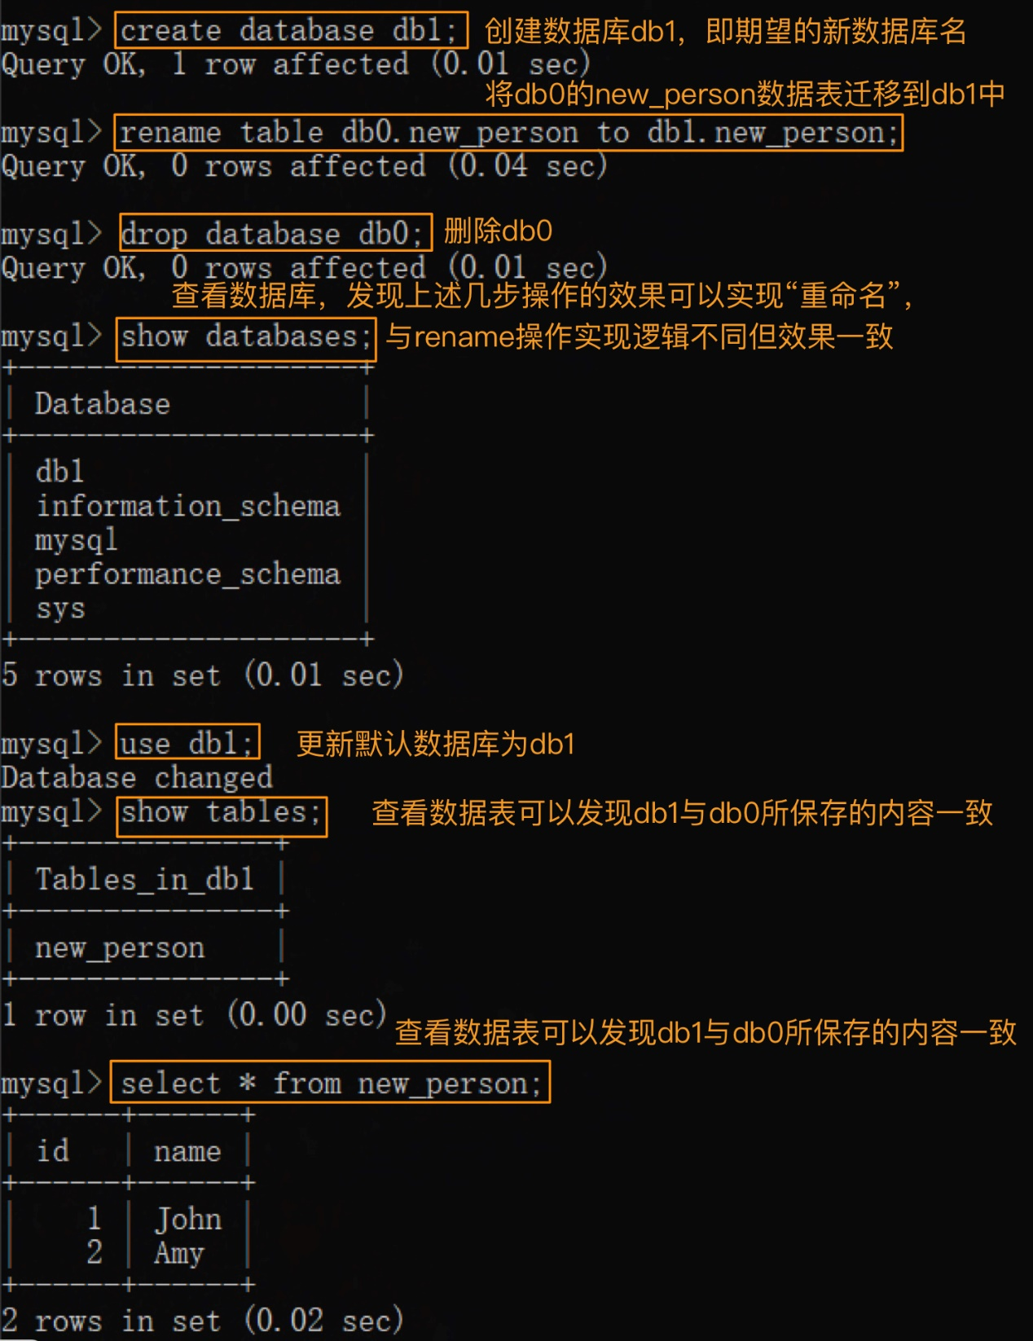
删除数据库、数据表、表内数据
drop database <name of the database>;
drop <name of the table>;
delete from <name of the table> where id = <content of id>；
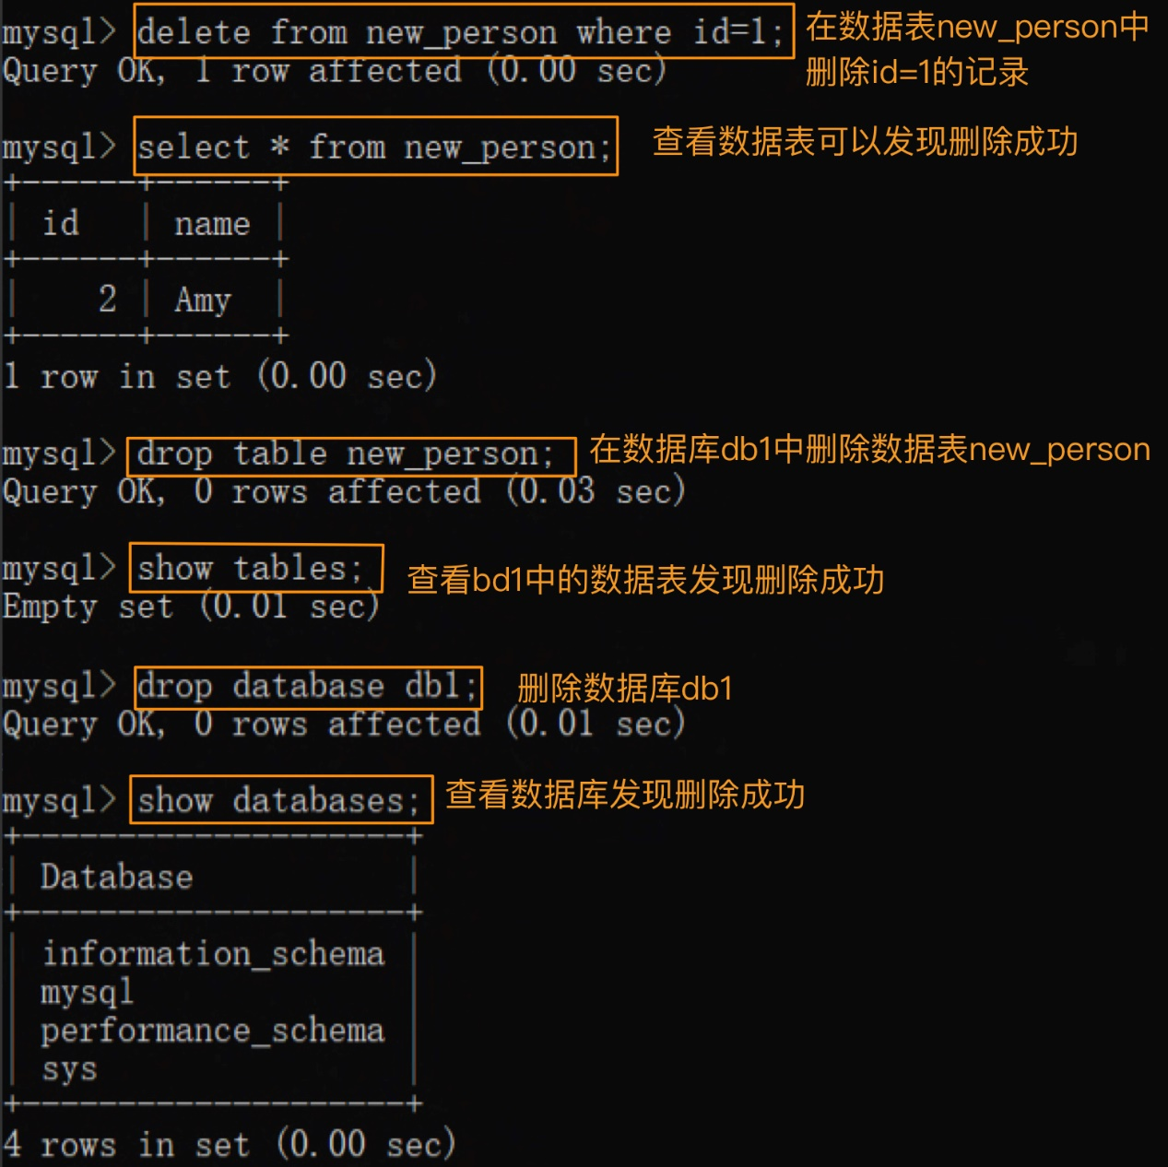
数据表结构操作
desc <name of the table>查看表结构
alter table <name of the table> add <field name><field type>增加列
alter table <name of the table> drop column <field name>删去列
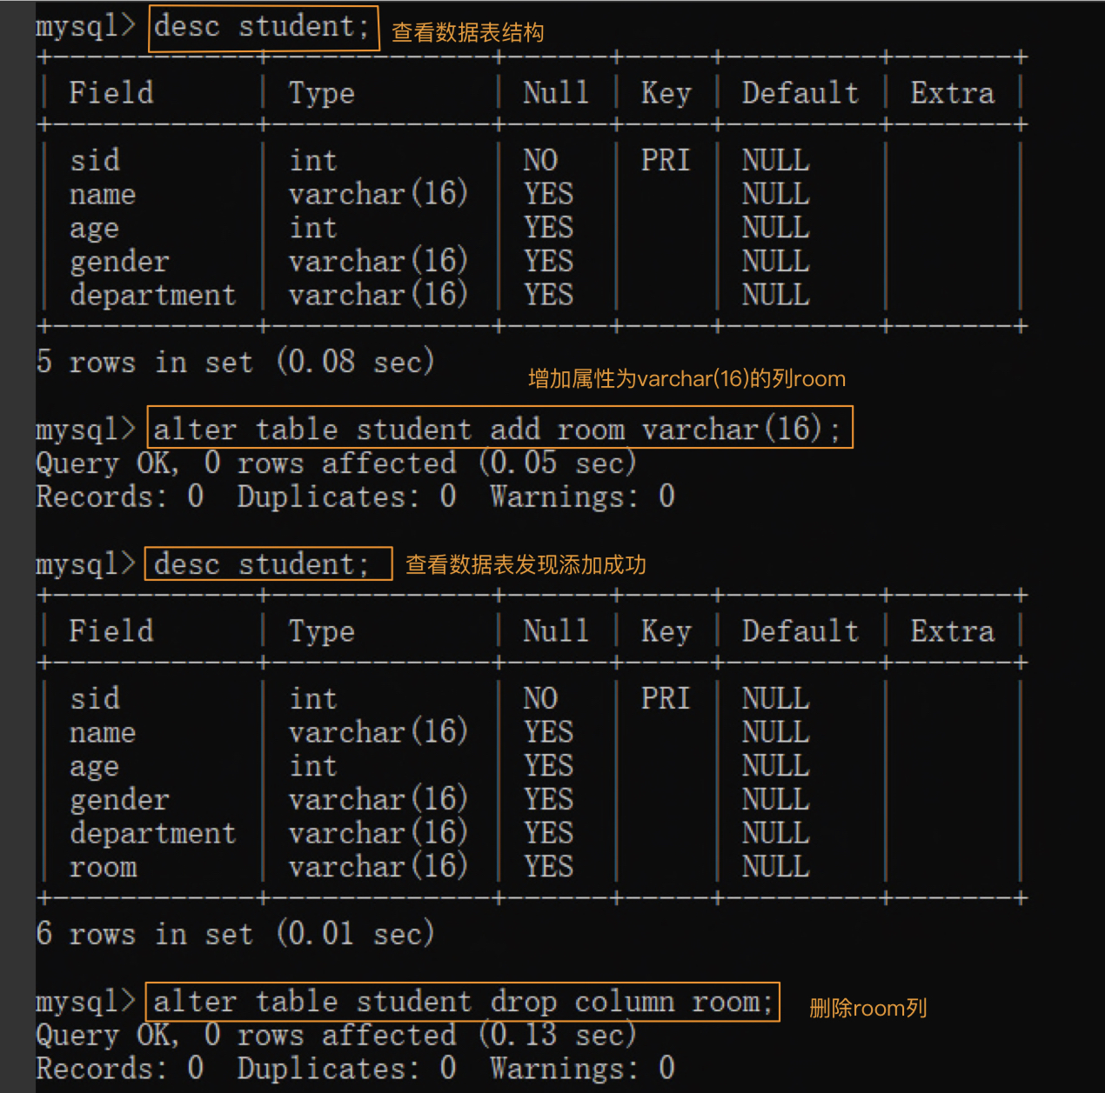
单表查询、多表查询、嵌套查询
建立数据库如下
create table student(sid int not null primary key, name varchar(16), age int, gender varchar(16), department varchar(16));
create table club(cid int not null primary key, name varchar(16), supervisor varchar(16));
create table member(cid int not null, sid int not null, primary key(cid,sid));
插入一定量数据
insert into student values (1,'Amy',16,'female','CS'), (2, 'Allen',17, 'male', 'CS'),(3, 'Aren',17, 'male', 'EE'), (4,'Dantein',17,'male','CS'), (5, 'Ella',16, 'female', 'EE'),(6, 'Sarah',18, 'female', 'AI'),(7, 'John',16, 'male', 'EE'), (8, 'Mike',16, 'male', 'CS'),(9, 'Seline',16, 'female', 'AI'), (10, 'Jason',18, 'male', 'AI');
insert into club values(1,'Dancing club','JL Sun'), (2,'Singing club','JL Sun'), (3,'Tennis club','Mr.Lou'), (4,'Volleyball club','Mr.Li');
insert into member values(1,1),(1,2),(2,3),(3,2),(4,3),(1,7),(3,7),(4,9),(3,8),(1,6),(2,6);
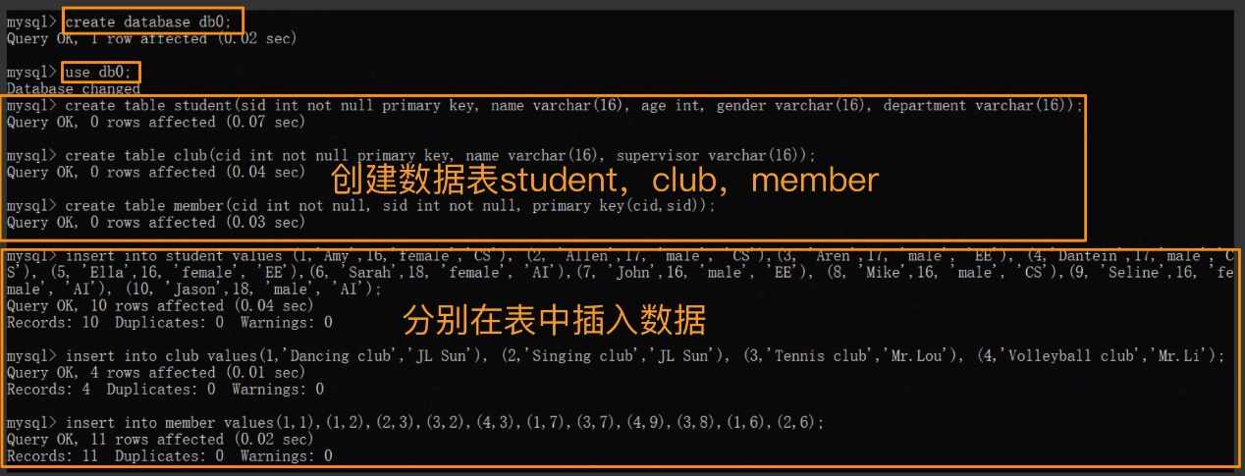

单表查询Find the name of students from the CS department.
select name
from student
where department='CS';
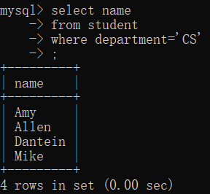
多表查询Find the of students from the CS department who is a member of the Dancing club.
select sid
from member,club
where club.cid=member.cid and club.name='Dancing club';
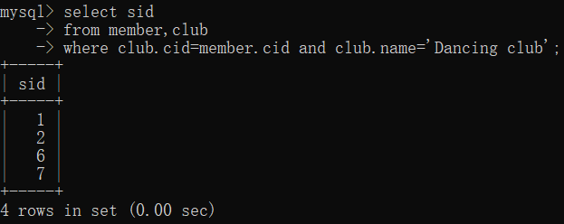
嵌套查询Find the of students from the CS department who is a member of the Dancing club.
select name
from student
where department='CS'
and sid in(select sid
from member,club
where club.cid=member.cid and club.name='Dancing club');
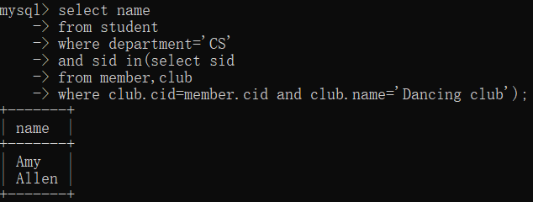
随便查点东西Find the name of students who is a member of any club supervised by JL Sun.
select sid,name
from student
where sid in (select sid
from club,member
where club.cid=member.cid and club.supervisor='JL Sun');
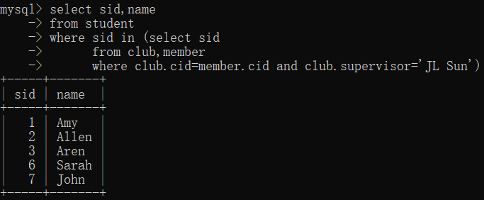
随便查点东西Find the two students with the biggest age difference.
select s1.sid, s2.sid
from student as s1, student as s2
where s1.age –s2.age>=all
( select s3.age-s4.age
from student as s3, student as s4);
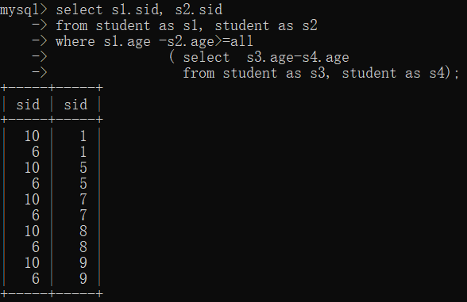
创建、查看、删除索引
create index <name of the index> on <name of the table> (<field name>)
show index from <name of the table>
drop index <name of the index> on <name of the table>
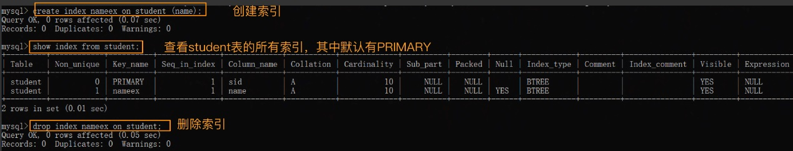
创建、查看、修改、删除视图
create view <name of the view> as select <field name>from <name of the table>where<>;
select * from membership;
update membership set gender='female' where sid=2;
drop view membership;
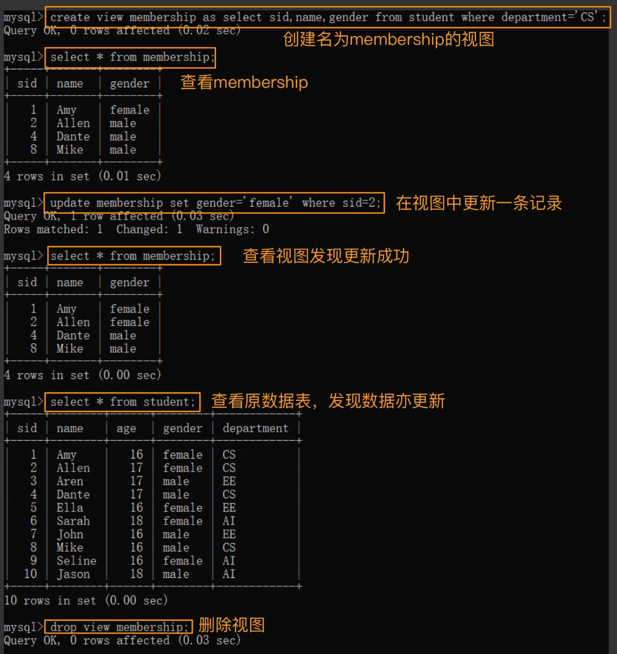
四、遇到的问题及解决方法
无
五、总结
//

